**More targeted measures needed to support Roma women**

Rights areas:

* [Roma](https://fra.europa.eu/en/taxonomy/term/980)

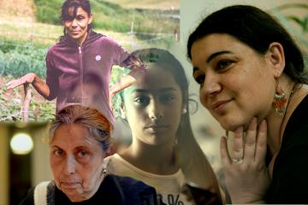

Women throughout the EU face inequalities. But Roma women face additional challenges such as anti-Gypsyism, extreme poverty, exclusion and discrimination which reinforce their disadvantages, according to the latest report from the European Union Agency for Fundamental Rights. It underlines the urgent need for targeted, gender-sensitive measures that allow Roma women to realise their full potential.

**Publication**

[**Second European Union Minorities and Discrimination Survey Roma – Selected findings**](https://fra.europa.eu/node/23292)

Ahead of International Roma day on 8 April, FRA is issuing its [Second European Union Minorities and Discrimination Survey: Roma women in nine EU Member States](http://fra.europa.eu/en/publication/2019/eumidis-ii-roma-women) report. It shows that while women generally suffer from inequality, it is particularly acute for Roma women. Overall, they:

* leave school early - only 16% of Roma women have completed upper secondary education compared with 22% of Roma men and 75% of European women;
* marry young - 29% of Roma women compared with 12% of Roma men are married before they turn 18;
* stay at home - 40% of Roma women are not looking for work due to their care responsibilities; this is often twice as high as general population women;
* are not in paid work - only 16% of Roma women are employed compared with 34% of Roma men.

These figures underline the need for Roma inclusion measures that are gender-sensitive, and designed and implemented together with Roma women. They show that we need to examine carefully how to combine social welfare support with opportunities for decent work.

They also point to the negative consequences of a lack of access to early childhood education and care, which could provide Roma women with the time to learn skills and seek employment.

They call, in particular, for giving a strong and prominent voice to Roma women in public life and within their own communities.

The report draws on information collected in nine EU Member States from nearly 8,000 face-to-face interviews with Roma. The information is drawn from the agency’s [EU-wide survey of minorities of their experiences and perceptions of discrimination and harassment](https://fra.europa.eu/en/project/2015/eu-midis-ii-second-european-union-minorities-and-discrimination-survey).